M02-1: SL and Practice

How to bring “Service Learning” in practice?

A) Clarifying
1. Brainstorm: collecting ideas (teachers and learners)
- Define the problem (definition phase)
- Discuss the problem grounded by information (information phase)
- Concreate the problem (new-definition phase)
- Concreate ideas (idea phase)
- Sort in categories (examination phase)
2. Partner Search: identifying and finding cooperation partners (agencies, grants, institutions, local partners etc.)
3. Curriculum: clarifying the connecting between current and former seminars, expected learning outcome and study aims

B) Setting the primary focus
What should be reached: what are the resources of the group, their prior experiences, their knowledge –> what can be reached?
(e.g. overcoming the theory-practice-gap, supporting to be a participating member of the society, democracy, scientific knowledge, social competences live-long-learning, planning skills, building relationships, getting research results, supporting critical thinking, problem-solving, offering job chances, see M02-2: Service Learning in Educational Domains.
- “academic expectancies” (learning growth)
- “service expectancies” (social effect)
- “Personal growth expectancies” (personal competence gain)

Course:
Give the three months course a structure and keep the Service-Learning Standards for Quality Practice in mind (M02-3).
- Introductory workshop/seminar (clarifying frame, organisational aspects, scientific and social context: practical aspects / scientific aspects / social aspects)
- Connection and trust building to the cooperation partners (getting to know new social fields and acting adequate)
- Encouraging active role of the learners (acting, responsibility, problem solving, experiencing something new)
- Encouraging teamwork of the learners (sensible in between the students working group and in between the service giver/taker-connection, avoiding disappointing and in transparent events)
- Encouraging meta reflection (exploration of the reasons for the main problem and concrete raising problems; bringing the own role, points of views, problems to mind)
- Evaluating the pedagogical win, effects, problems of the project (drawing a balance)
Here an overview:
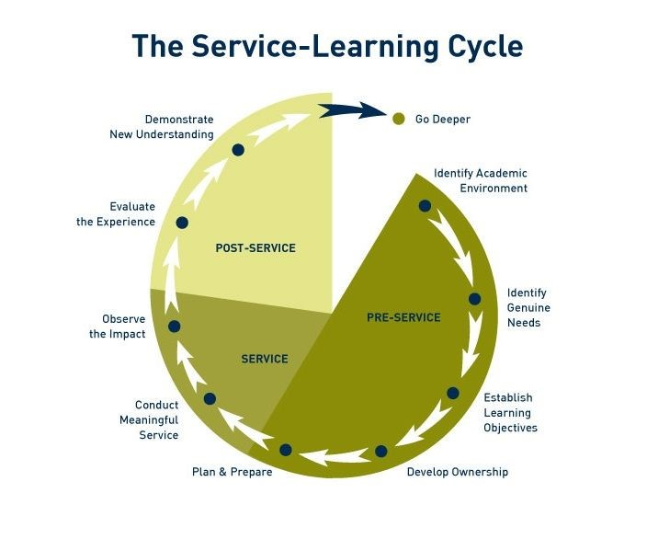
Source: https://i.pinimg.com/736x/2f/b3/7e/2fb37e69e503afc8864a0a0cbb7e923f--school-volunteers-student-volunteer.jpg

