W04-2: Create your own portfolio
On this worksheet you learn how to create your own ePortfolio using the platform “Mahara”. You will also practice writing a reflection.

Things you need for this session
- your web browser (e.g. Firefox, Chrome)
- maybe some photos and texts to implement in your portfolio

Learning log assignments
- Visit the website www.mahara.org and log in (User: student; password: MaharaDemo).
- Create a new page.
- Write a short reflection about one (!) experience in the summer school so far. Try to follow the helix of reflection (see below)!
- Create a new collection.
- Implement the reflection in your collection
- Implement your homework from “W01-1: Your teaching experience”.
- Implement some photos or other pictures to illustrate your writing.
- Share your portfolio (or at least the page “reflection”) with your neighbor.
- Write a comment on your neighbor’s portfolio.
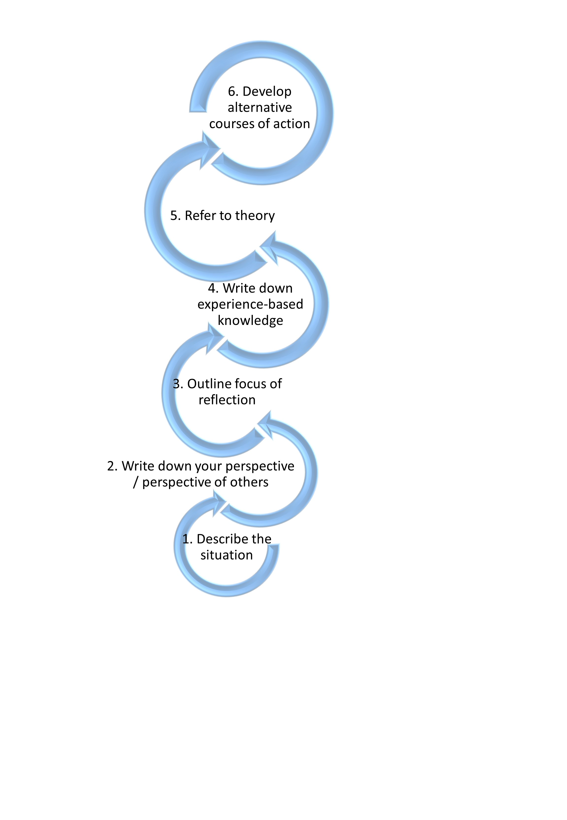Helix of reflection

