E01-1 Comparison of Landsat 8 and Sentinel-2
Basically there are two different types of sensor systems used for satellite based earth observation. On the one hand are passive systems which detect (reflected) radiation emitted by sun or earth. These are multispectral or hyperspectral sensors, depending on the number of bands they use for radiation detection. On the other hand are active sensors which emit radarwaves or laserbeams and detect the reflected radiation as well as its travel time which allows calculation of distances. An overview of different satellites, their sensors geometric resolution, operational lifes and their revisiting time at the equator is presented in figure 1. Two platforms - Landsat 8 and Sentinel-2 -, which are carrying passive sensor systems, as well as their respective programs, are shortly presented and compared afterwards.
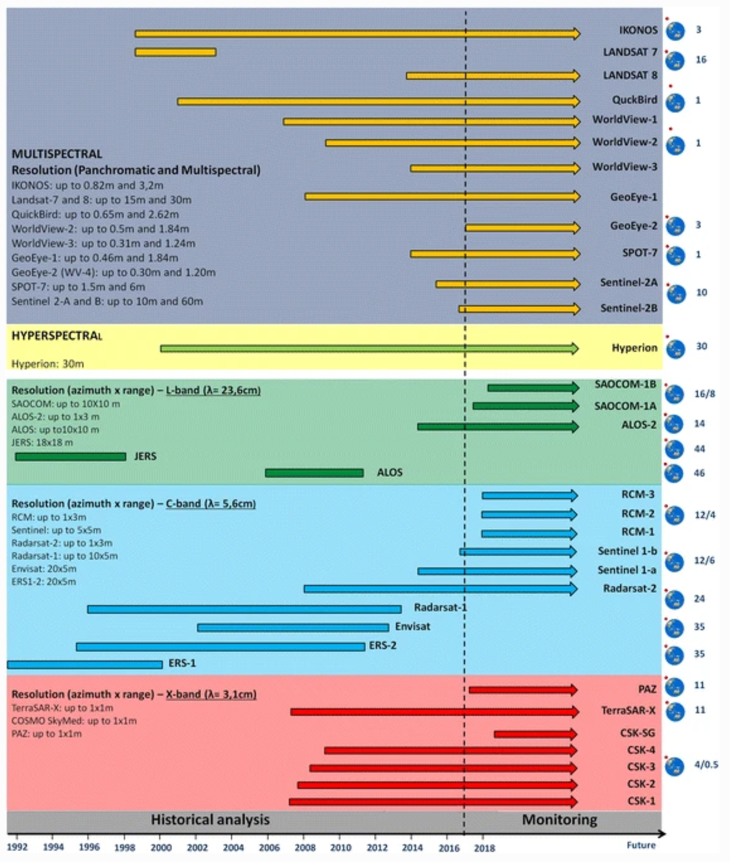Operating optical and SAR satellites for earth observation. The numbers on the right of the figure report the revisting time of each satellite at the equator.

Landsat program
The Landsat program, which started with its first satellite launch in 1972, is the oldest ongoing remote sensing program on earth. It is co-operated by the National Aearonautics and Space Administration (NASA) and the United States Geological Survey (USGS). The first satellite was followed by seven similar satellites with ongoing improvement and adding of newly developed sensors. The longest operational life so far was reached by Landsat 5 in 2013 with more than 29 years which is the world record in that discipline. Landsat 6 got lost during the launch and has never reached its planned orbit. Landsat 7, which started in 1999, is still operating today but has its scanline correction down since 2003 what results in flawed images. Nevertheless this is only true for the edges of the images, so the rest of them still can be useful. Landsat 8 started in 2013 and is operating perfectly fine. The Launch of Landsat 9, totally identic to its predecessor, is planned for 2021. Altogether, due to its similarity and the long operating time since 1972, the Landsat program produced, despite the middle geometric resolution, an extremely valuable archive.

Sentinel missions
The Sentinel missions are part of the Copernicus Program for earth observation of the European Union. In charge of management and coordination is mainly the European Commission together with the European Space Agency (ESA) which is the actual operator of the Sentinel missions. Sentinel is the name of the satellites of which 6 (3 pairs of identic satellites each on the same orbit with an offset of 180°) are operating right now. The first pair started in 2014 with Sentinel-1A (2016 Sentinel-1B) and is carrying an active radar sensor each. Sentinel-2A and -2B were launched in 2015 and 2017 respectively and provide high-resolution optical imaging for land services. According to ESA two more satellites with the same sensor (Sentinel-2C and -2D) should be launched soon, followed by a new generation of that type in the next years to ensure ongoing operation. Sentinel-3A and -3B were launched in 2016 and 2018 and provide ocean and global land monitoring services. There are additional Sentinel missions (up to Sentinel-12) with different purposes planned and discussed.

Landsat 8 vs Sentinel-2
All of the images produced by Landsat 8 and Sentinel-2 are free of charge, upon registration (this is also true for all products of the Landsat and Sentinel program). Where to find and download them is outlined on the page E01-2 Overview of data sources. The purpose of both platforms is long-term earth observation for mapping, monitoring and analysis at middle to high geometric resolution. It enables a wide spectrum of application in geography, geology, agriculture, forest, land-use planning and others. Sentinel-2 satellite pair is applicable also for disaster management and emergency response due to its comparably short re-visiting time of 5 days at the equator.

Technical specifications
 |  | Landsat 8 | Sentinel-2
Resolution | spectral | Band 1: 0.433-0.453 μm (aerosols),  Band 2: 0.450-0.515 (Blue),  Band 3: 0.525-0.600 μm (Green),  Band 4: 0.630-0.680 μm (Red),  Band 5: 0.845-0.885 μm (NIR),  Band 6: 1.560-1.660 μm (SWIR),  Band 7: 2.100-2.300 μm (SWIR),  Band 8: 0.500-0.680 μm (Pan),  Band 9: 1.360-1.390 μm (SWIR),  Band 10: 10.30-11.30 µm (LWIR),  Band 11: 11.50-12.50 µm (LWIR) | (Central wavelengths)  Band 1: 443 nm (aerosols),  Band 2: 490 nm (Blue),  Band 3: 560 nm (Green),  Band 4: 665 nm (Red),  Band 5: 705 nm (RedEdge),  Band 6: 740 nm (RedEdge),  Band 7: 783 nm (RedEdge),  Band 8: 842 nm (NIR),  Band 8a: 865 nm (NIR),  Band 9: 945 nm (NIR),  Band 10: 1375 nm (NIR),  Band 11: 1610 nm (SWIR),  Band 12: 2190 nm (SWIR)
Resolution | radiometric | 12-bit, 4096 grey levels | 12-bit, 4096 grey levels
Resolution | geometric | Band 1-7, 9: 30 m,  Band 8: 15 m,  Band 10, 11: 100 m | Band 2-4, 8: 10 m,  Band 5-7, 8a, 11, 12: 20 m,  Band 1, 9, 10: 60 m
Resolution | temporal | 16 days at the equator | 5 days at the equator
Tile / granule size |  | 185 x 180 km | 100 x 100 km
Links |  | website of the program,  interactive online-viewer for Landsat data | website of the program,  multiple examples of applications,  interactive online-viewer for Sentinel-2 data,  tracking Sentinel-2B

