W03-2: Constructive Alignment
This worksheet deals with the most important aspects of designing and organizing the learning experience for your students.
Think of the following situation:
A colleague tells you about the course he is giving next semester. It is his first course and he has barely any idea of where to start since he hasn’t had any teaching experience yet. He only knows the rough topic he wants to talk about: Biodiversity. But what to tackle first? Looking for possible contents and the latest research? Finding interesting teaching methods? Or should he start by creating worksheets and formulating tasks for the first lesson and go week by week? And what about media - will he be teaching online via a learning platform or in person? He asks you to support him in creating a plan to feel less overwhelmed. Of course, you agree ☺ You write down the key points of his questions on different indexcards.
1. With a partner, look at the following key points and bring them into a sensible order. Discuss: what would you start with? Give reason for your order. Add points if needed.
- Identifying topics & subtopics on Biodiversity
- Developing grading criteria for assessment
- Looking up the latest research on Biodiversity
- Set a timeframe for the whole semester (e.g. how many lessons there are)
- Estimating students’ previous knowledge
- Set learning outcomes
- Identify assessment strategies
- Identify Teaching and Learning activities
- Set levels of learning outcomes (levels of understanding/of performance)
- Communicating learning outcomes to students
- Set timeframes to achieve the (different levels of) learning outcomes
Your colleague is very thankful for your help. Let’s see if you can help him to fit these ideas into a larger framework that he can reapply over and over again by using the concept of “Constructive Alignment”. This concept is used to align desired learning outcomes with learning activities, teaching activities and assessment (Fig. 1). For an overview and as accompanying material you can work with Aligning Assessments with Learning Outcomes along with this course. This is optional, of course.
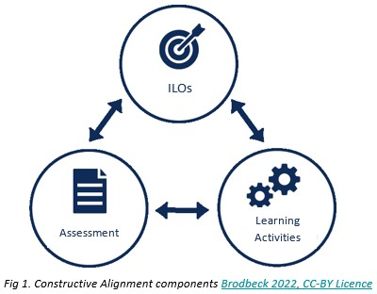
2. Watch the Google Slides Screencast and discuss whether you agree with the suggestions made in the concept of “Constructive Alignment”. Rearrange points in your list if needed. Highlight the index cards mentioned in the “four steps of constructive aligned teaching and assessment”.
Now let’s focus on the intended learning outcomes (ILOs) in your own teaching.
3. Use this worksheet W03-1 to individually formulate the ILOs for a future course or for a course that you planned or implemented in the past. Please think of one course in particular while formulating your ILOs. After formulating your ILOs - let’s follow the four steps of constructively aligned course development further and have a look at how to create an aligned learning environment.
4. Watch this Google Slides Screencast on Teaching and Learning Activities.
5. Choose one of your ILOs you listed previously. Think of teaching and learning activities that suit this ILO. Use the information in the Google Slides Screencast and find further information on teaching methods here (focus on pp. 3-8) and here. Now complete your worksheet W03-1 My ILO's, section g.

